**Mild to Moderate evaluation:**

Sample_Id:**EKYYAC**

Link:<https://release.animalbiome.com/pet/assessment/report/summary/223efb6f-a7f8-4b9d-9ec1-522fc9582bc9>

Mild to Moderate:

Cats and dogs:

Any Two

(High Yellow Flag Megamonas OR (failed)

High Yellow Flag Sutterella OR (**Passed**)

High Yellow Flag Collinsella OR (failed)

Low Yellow Flag Bacteroides OR (failed)

Low Yellow Flag Blautia (**Passed**)

)

OR Cats: 8-10 Yellow Flags(Failed)4

OR 5-8 Red Flags;(Failed)2

OR dietary recommendation of increase fiber (**Failed**)

or protein or decrease carbs(**Failed**)

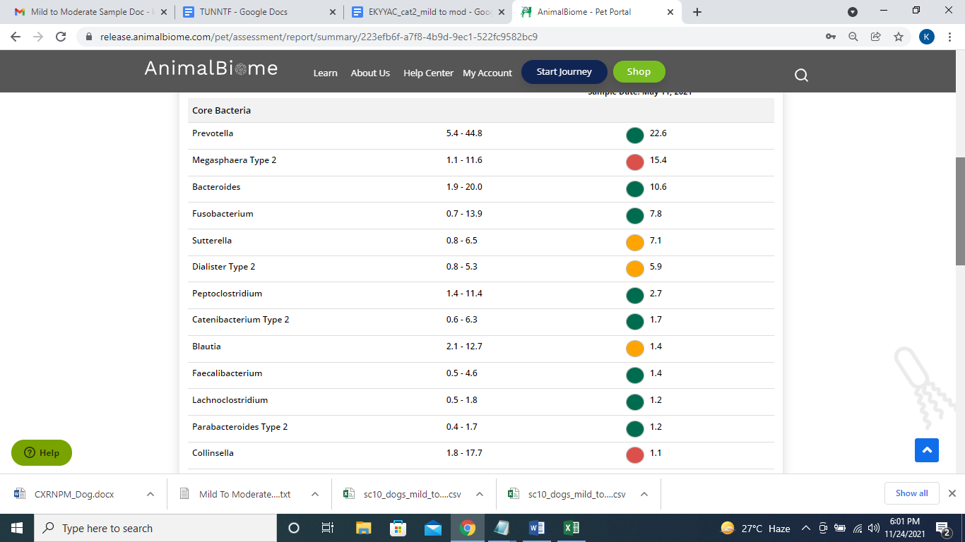

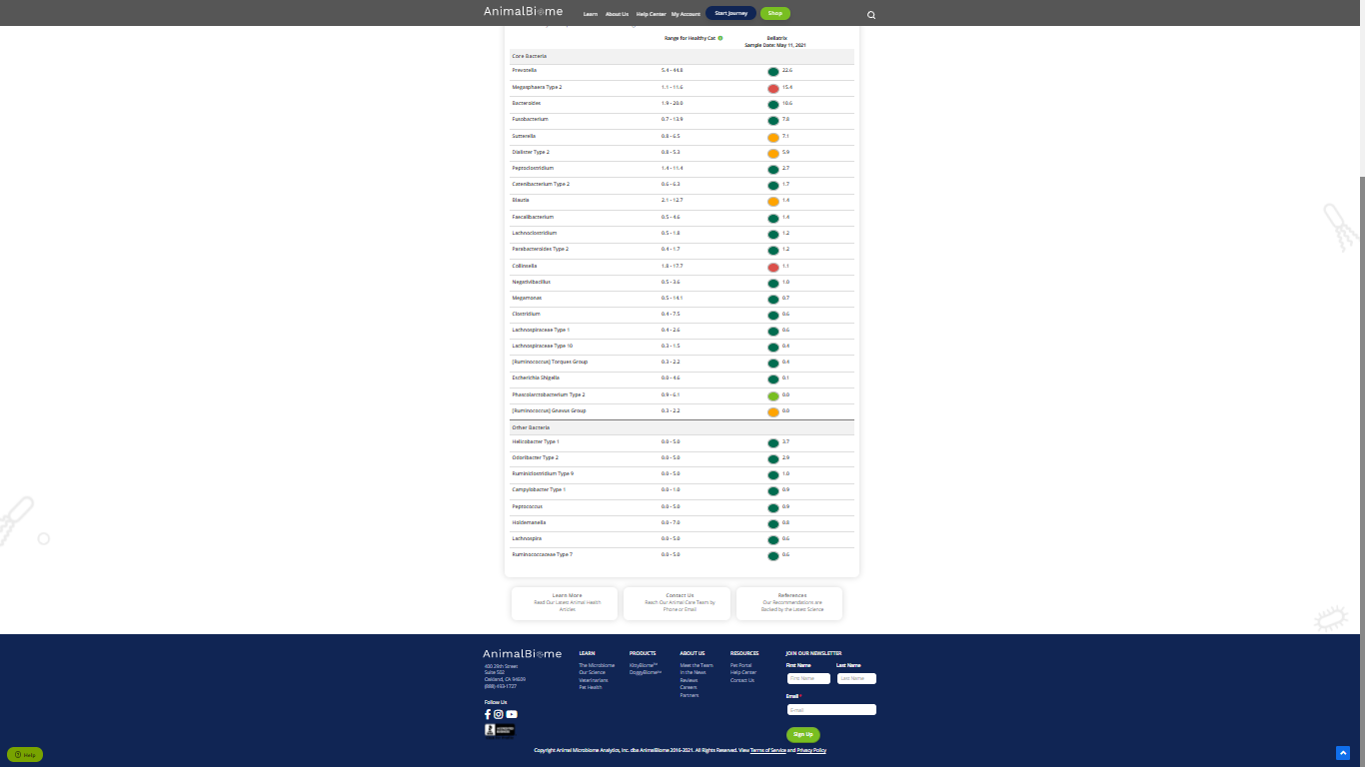

The result : **True False False False**

Mild to moderate evaluation results:Pass

Expected result : Mild to moderate

Achieved result : **passed.**

